SOFTWARE REQUIREMENT SYSTEM (SRS) FOR SEMINAR HALL BOOKING WEBSITE

1.PURPOSE:

The purpose of this SRS is to define the functional and Non-functional requirements for the “Seminar Hall Booking Website”. The system will allow students, faculty, and administrators to efficiently reserve seminar halls for academic and Non-academic events, avoiding conflicts and double bookings

2.SCOPE:

The Seminar Hall Booking Website will :-

* Allow Clients to search the available seminar halls and the slots
* Maintain a booking history and generate reports.
* Provide an special authentication for Admins and staffs
* Notify the dates earlier to the client through the email

3.BENEFITS:

* Reduces manual effort and paperwork.
* Provides accurate slot timings to the clients.
* Improves efficiency and accessibility.

4.USERS CLASSES AND CHARACTERISTICS:

* ADMIN: Authority responsible for approving/rejecting bookings
* USERS: Can access limited features like searching and borrowing books.

5.SPECIFICATION REQUIREMENTS:

5.1 FUNNCTIONAL REQUIREMENTS:

* LOGIN MODULE: The system shall allow users to register and log in.
* SEARCH FACILITY: The system shall allow users to search available seminar halls by date/time.
* MEMBER MANAGEMENT:

1. The system shall allow users to submit booking requests with event details.
2. The system shall allow admins to approve or reject booking requests

* SLOT ALLOTMENT: The system shall prevent double-bookings by checking hall availability.
* NOTIFICATION: The system shall send notifications (email) upon booking status update.
* REPORTS: The system shall allow admins to generate booking reports.

5.2 NON-FUNCTIONAL REQUIREMMENTS:

* PERFORMANCE: The website shall load within 3 seconds
* SECURITY: Only authenticated users can access the system.
* USABILTY: Easy-to-use interface for both admin and users.
* RELIABILITY: 99% uptime for web-based version.
* DATABASE: All booking data shall be stored securely in the database

5.3 EXTERNAL INTERFACE REQUIREMENTS:

* USER INTERFACE: Responsive web pages, dashboard for client/receptionist, admin control panel.
* HARDWARE INTERFACE: Cloud-based server hosting, Email gateway.
* SOFTWARE INTERFACE: Database connection (MySQL, PostgreSQL).

6.SYSTEM MODEL:

6.1 USE CASE DIAGRAM:

* ACTOR: Admin, User
* USE CASE: Login, View Available Halls, Book Seminar Hall, Manage Hall Details, Cancel booking, Generate Report.

6.2 DATA FLOW DIAGRAM:

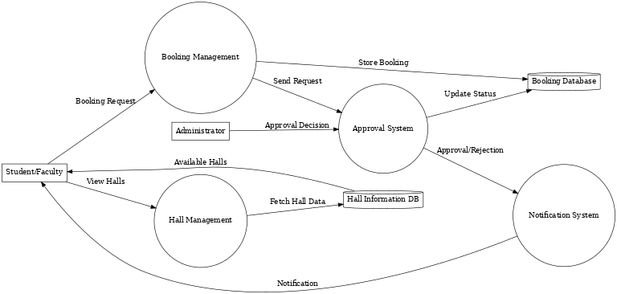

* LEVEL 0: Admin/user interact with SBW.
* LEVEL 1: Booking Management, Hall Management, Approval System, Notification System.

6.3 ENTITY-RELATIONSHIP (ER) DIAGRAM:



7.APPENDIX:

* FUTURE SCOPE: Online Hall booking will be familiar to people.
* LIMITATIONS: Pre booking is available for only a Week before.